Place Order as Student

Document Information

|  |  |
| --- | --- |
| **Document Title** | Title of use case – Verb Noun phrasing is almost always the most appropriate! |
| **Document Owner** |  |
| **Version** |  |
| **Status** |  |
| **Date** |  |

1. Brief Description

This use case allows the student to place an order for lunch on a specific day.

1. Actors

* Student

1. Trigger

The student decides to place an order for lunch on a specific day.

1. Pre-Conditions

* The student must be logged in to the system.
* The student has sufficient balance in their account to pay for the selected food items.
* The selected day is not the day in the past.

1. Post-Conditions

* The student’s account balance is reduced by the amount of the order.
* The order is added to the list of orders for the selected day of the student and the school administrator.
* An order code is generated and displayed to the student for later use.

1. Basic Flow
2. The student logs in to their account on the School Lunch Ordering System.
3. The student selects the day they want to order for.
4. The student selects the food items and quantity.
5. The student confirms the order by selecting “Confirm” button.
6. The system deducts the amount from the student’s account balance.
7. The system generates the order detail including an order code, order time, food item,… at the “My Order” menu.
8. The system returns the student to “My Order” page.
9. Alternate Flows
10. Exception Flows

* 4a. If the student does not have sufficient balance in their account, the system will prompt an error message to tell the student to top up their account before proceeding with the order. The system then returns to step 3.

1. Business Rules

* The student can only order up to the maximum quantity allowed for each food item.
* The student can only order up to the balance amount in their account.

1. Non-Functional Requirements

* The system should process the order quickly to prevent delays for other users (1s).
* The system should provide clear and concise messaging to the student throughout the ordering process.

1. Supplemental Requirements
2. Visual Model

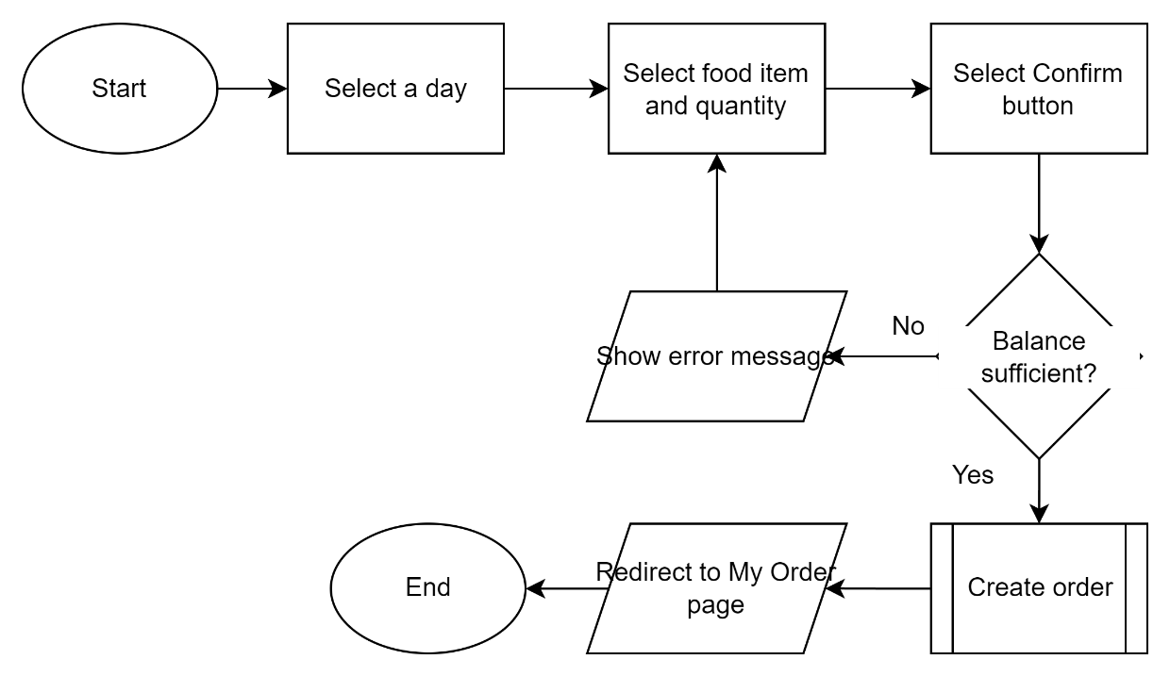

Revision History

|  |  |  |  |  |
| --- | --- | --- | --- | --- |
| V. | Date | Author | Description | Status |
|  |  |  |  |  |
|  |  |  |  |  |